Paper title, Times New Roman font size 15 or author can directly select article title from styles of this template
First Author ^{1 *}, Second Author ², Third Author ³ (Times New Roman, Font Size -11; First Name-Middle name optional followed by Last name/Family name; Author can use authors name from styles)
¹ Affiliation, Department, Institute, City, State, Country (Times New Roman, Font Size -10, center align, select Affiliation style)
² Affiliation, Department, Institute, City, State, Country
³ Affiliation, Department, Institute, City, State, Country
(Example- Professor, Department of XYZ Management, Institute Name, City, state, Country)

Publication history: Received: April 19, 2025; Revised: May 27, 2025; Accepted: May 30, 2025
Article DOI: Do not write here anything, proof editor will enter this information

Abstract (IJSAIR-h-Abstract title)
The abstract should provide a concise summary of the entire paper and must be written in a single paragraph of no more than 250 words. It should be formatted in Times New Roman, font size 10, using the Normal style from the template. The abstract must clearly state the overall purpose of the study, the basic design or methodology, a summary of the key results or findings, and a brief interpretation or conclusion based on those results. It should be specific, informative, and self-contained, allowing readers to understand the scope and significance of the research without needing to refer to the full text. Additionally, the abstract must include at least one sentence that explicitly identifies which specific United Nations Sustainable Development Goal (SDG) the study addresses, and how the study contributes to it. This section should be treated as a “live” element of the template and kept updated in accordance with any changes made to the main text. The abstract should provide a concise summary of the entire paper and must be written in a single paragraph of no more than 250 words. It should be formatted in Times New Roman, font size 10, using the Normal style from the template. The abstract must clearly state the overall purpose of the study, the basic design or methodology, a summary of the key results or findings, and a brief interpretation or conclusion based on those results. It should be specific, informative, and self-contained, allowing readers to understand the scope and significance of the research without needing to refer to the full text. Additionally, the abstract must include at least one sentence that explicitly identifies which specific United Nations Sustainable Development Goal (SDG) the study addresses, and how the study contributes to it. This section should be treated as a “live” element of the template and kept updated in accordance with any changes made to the main text.
Keywords: Keyword 1; Keyword 2; Keyword 4; Keyword 5; Keyword 6

Introduction (Heading 1, IJSAIR heading level 1)
The introduction should be typed in Times New Roman with font size 10. Author can select Normal style setting from Styles of this template. The simplest way is to replace (copy-paste) the content with your own material. In this section highlight the importance of topic, making general statements about the topic and presenting an overview on current research on the subject. Your introduction should clearly identify the subject area of interest.
References should be cited at the appropriate point in the text using the author’s last name and year of publication in parentheses. For example: “...was reported earlier (Prasad, 2013; Briggs & Freeman, 2011).”
References should be cited at the appropriate point in the text using the author’s last name and year of publication in parentheses.
e.g.: "…was reported earlier (MacDougall et al., 2011; Prasad et al., 2013)."
The introduction should be typed in Times New Roman with font size 10. Author can select Normal style setting from Styles of this template. The simplest way is to replace (copy-paste) the content with your own material. In this section highlight the importance of topic, making general statements about the topic and presenting an overview on current research on the subject. Your introduction should clearly identify the subject area of interest.
The introduction should be typed in Times New Roman with font size 10. Author can select Normal style setting from Styles of this template. The simplest way is to replace (copy-paste) the content with your own material. In this section highlight the importance of topic, making general statements about the topic and presenting an overview on current research on the subject. Your introduction should clearly identify the subject area of interest.

Material and methods (Heading 1, IJSAIR heading level 1)

Heading 2, IJSAIR Heading level 2
The materials and methods should be typed in Times New Roman with font size 10 and justify alignment. Author can select Normal style setting from Styles of this template. The simplest way is to replace (copy-paste) the content with your own material. Method and analysis which is performed in your research work should be written in this section. A simple strategy to follow is to use keywords from your title in first few sentences.

Heading 3, IJSAIR Heading level 3

References should be cited at the appropriate point in the text using the author’s last name and year of publication in parentheses.
e.g.: "…was reported earlier (MacDougall et al., 2011; WHO, 2022).

Heading 4, IJSAIR Heading level 4
The actual authors can be referred to in the text, but the year of publication must always be included in parentheses.
Heading 2, IJSAIR Heading level 2
The materials and methods should be typed in Times New Roman with font size 10 and justify alignment. Author can select Normal style setting from Styles of this template. The simplest way is to replace (copy-paste) the content with your own material. Method and analysis which is performed in your research work should be written in this section. A simple strategy to follow is to use keywords from your title in first few sentences.

Results and discussion (Heading 1, IJSAIR heading level 1)
This section should be typed in character size 10pt Times New Roman and alignment justified. Author can directly select Normal style from styles of this template. The results and discussion may be combined into a common section or obtainable separately. They may also be broken into subsets with short, revealing captions. An easy way to comply with the conference paper formatting requirements is to use this document as a template and simply type your text into it.
Article Subheadings as well as Article sub-sub headings formatting can be used as in material and methods section
References should be cited at the appropriate point in the text using the author’s last name and year of publication in parentheses.
e.g.: "…was reported earlier (MacDougall et al., 2011; Prasad et al., 2013)."
The actual authors can be referred to in the text, but the year of publication must always be included in parentheses.
e.g.: “Barnaby and Jones (2019) obtained a different result…”

Heading 2, IJSAIR Heading level 2
The materials and methods should be typed in Times New Roman with font size 10 and justify alignment. Author can select Normal style setting from Styles of this template. The simplest way is to replace (copy-paste) the content with your own material. Method and analysis which is performed in your research work should be written in this section. A simple strategy to follow is to use keywords from your title in first few sentences.

Heading 3, IJSAIR Heading level 3
References should be cited at the appropriate point in the text using the author’s last name and year of publication in parentheses.
e.g.: "…was reported earlier (MacDougall et al., 2011; Prasad et al., 2013)."

Heading 4, IJSAIR Heading level 4
The actual authors can be referred to in the text, but the year of publication must always be included in parentheses.
e.g.: “Barnaby and Jones (2019) obtained a different result…”

Heading 2, IJSAIR Heading level 2
The materials and methods should be typed in Times New Roman with font size 10 and justify alignment. Author can select Normal style setting from Styles of this template. The simplest way is to replace (copy-paste) the content with your own material. Method and analysis which is performed in your research work should be written in this section. A simple strategy to follow is to use keywords from your title in first few sentences.
This section should be typed in character size 10pt Times New Roman and alignment justified. Author can directly select Normal style from styles of this template. The results and discussion may be combined into a common section or obtainable separately. They may also be broken into subsets with short, revealing captions. An easy way to comply with the conference paper formatting requirements is to use this document as a template and simply type your text into it.
This section should be typed in character size 10pt Times New Roman and alignment justified. Author can directly select Normal style from styles of this template. The results and discussion may be combined into a common section or obtainable separately. They may also be broken into subsets with short, revealing captions. An easy way to comply with the conference paper formatting requirements is to use this document as a template and simply type your text into it.
This section should be typed in character size 10pt Times New Roman and alignment justified. Author can directly select Normal style from styles of this template. The results and discussion may be combined into a common section or obtainable separately. They may also be broken into subsets with short, revealing captions. An easy way to comply with the conference paper formatting requirements is to use this document as a template and simply type your text into it.
All tables should be inserted in the main text article at its appropriate place.
Table 1 Table title should be of font size 10pt, Times New Roman, justfy

SN. | Type | Seismic Zone | Displacement
1 | A | 1 | xxxxxx
2 | Font size 10 | Times New Roman | No space after paragraph
3 | Font size 10 | Times New Roman | No space after paragraph
4 | Font size 10 | Times New Roman | No space after paragraph
5 | Font size 10 | Times New Roman | No space after paragraph
6 | Font size 10 | Times New Roman | No space after paragraph
7 | Font size 10 | Times New Roman | No space after paragraph
8 | Font size 10 | Times New Roman | No space after paragraph
9 | Font size 10 | Times New Roman | No space after paragraph
Table foot note should be Font size 8, Times New Roman, Centre aligned, No space before paragraph
Result discussion section should be typed in character size 10pt Times New Roman and alignment justified. Author can directly select Normal style from styles of this template. The results and discussion may be combined into a common section or obtainable separately. An easy way to comply with the conference paper formatting requirements is to use this document as a template and simply type your text into it.
All figures should be inserted in the main text document at its appropriate place. Figures should be numbered as Figure 1, Figure 2, and Figure 3 etc.

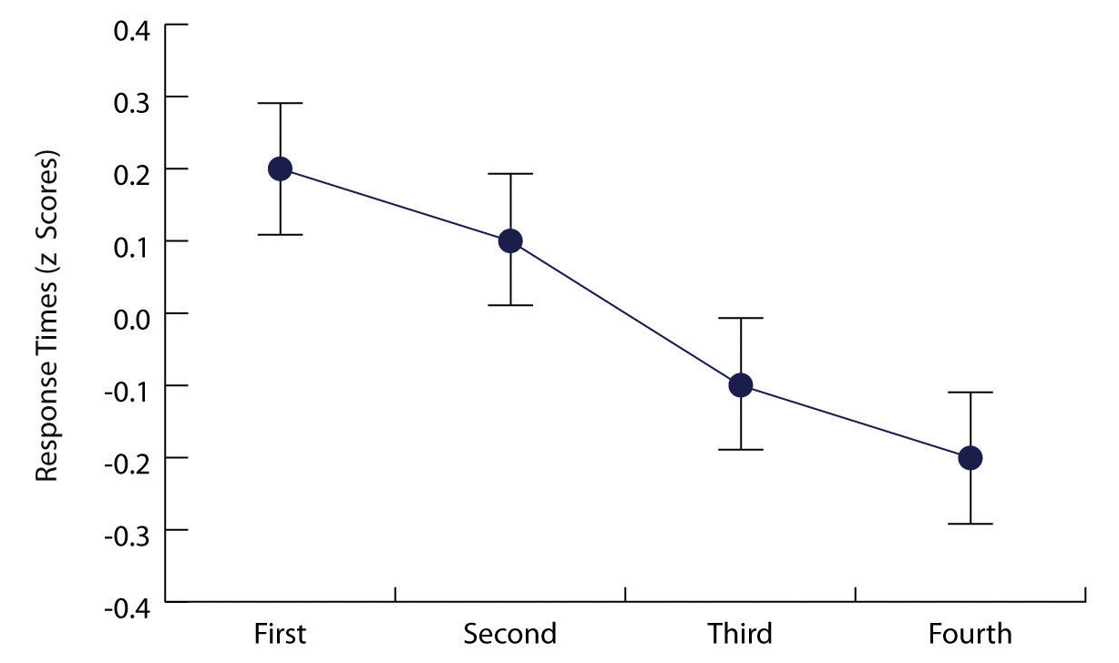
Figure 1 Figure caption should be of font size 10pt, Times New Roman, Centre align

Result discussion section should be typed in character size 10pt Times New Roman and alignment justified. Author can directly select Normal style from styles of this template. The results and discussion may be combined into a common section or obtainable separately. An easy way to comply with the conference paper formatting requirements is to use this document as a template and simply type your text into it.

Conclusion (Heading 1, IJSAIR heading level 1)
This section should be typed in character size 10pt Times New Roman and alignment justified. All the main points of the research work are written in this section. Ensure that abstract and conclusion should not same. Conclusion should be concise, informative and can be started with summarizing outcome of the study in 1-2 sentence and ended with one line stating: how this study will benefit to the society and way forward.

Compliance with ethical standards (IJSAIR-I-Heading no numbering)
Acknowledgements (optional) (IJSAIR-I-sub heading no numbering)
Author should write about third party like funding agencies, institution where experiment is carried out or who help in the experiment apart from authors.
Conflict of interest statement (optional) (IJSAIR-I-sub heading no numbering)
All the authors of must disclose the possible conflicts of interest/ Competing Interests they may have with publication of the manuscript or an institution or product that is mentioned in the manuscript and/or is important to the outcome of the study presented. Authors should also disclose conflict of interest with products that compete with those mentioned in their manuscript.
Statement of ethical approval (optional) (IJSAIR-I-sub heading no numbering)
If studies involve use of animal/human subject, authors must give appropriate statement of ethical approval. If not applicable then mention ‘The present research work does not contain any studies performed on animals/humans subjects by any of the authors.
Statement of informed consent (optional) (IJSAIR-I-sub heading no numbering)
If studies involve information about any individual e.g. case studies, survey, interview etc., author must write statement of informed consent as “Informed consent was obtained from all individual participants included in the study.

References (All references should follow APA format style of referencing.) (IJSAIR-I-Heading no numbering) (font size 9.5.)
Ariesmendi, D., Ridwansyah, A., & Sunitiyoso, Y. (2023). Drivers of customers advocacy in support of subscription-based digital entertainment services (netflix). International Journal of Current Science Research and Review, 06(09). https://doi.org/10.47191/ijcsrr/v6-i9-18
Chayomchai, A. (2021). Effects of service quality, satisfaction, and perceived loyalty in technology use of generation z consumers during the covid-19 situation. Journal of Southwest Jiaotong University, 56(4), 300-310. https://doi.org/10.35741/issn.0258-2724.56.4.25
Chen, H. and Hao, S. (2023). Dollar or percentage? the effect of reward presentation on referral likelihood. Asia Pacific Journal of Marketing and Logistics, 36(6), 1504-1519. https://doi.org/10.1108/apjml-07-2023-0678
Chen, V., Durán, P., Sauerwald, S., Hitt, M., & Essen, M. (2021). Multistakeholder agency: stakeholder benefit alignment and national institutional contexts. Journal of Management, 49(2), 839-865. https://doi.org/10.1177/01492063211054403
Fu, M. and Wang, D. (2021). Evaluation of crowdsourcing logistics service quality based on entropy weight method and analytic hierarchy process. E3s Web of Conferences, 257, 02082. https://doi.org/10.1051/e3sconf/202125702082
Gani, M., Ramlie, M., Ramli, I., Khairudin, K., & Pahme, N. (2023). Brand naming process in malaysia small and medium enterprise: a need assessment analyses. International Journal of Academic Research in Business and Social Sciences, 13(5). https://doi.org/10.6007/ijarbss/v13-i5/17078
Harriet, N., Arthur, N., Komunda, M., & Mugizi, T. (2024). Service quality, customer loyalty and customer retention among private health care services in mbarara city. Open Journal of Social Sciences, 12(01), 101-126. https://doi.org/10.4236/jss.2024.121008
Omar, N., Kassim, A., Nazri, M., & Sidek, F. (2018). The impact of customer value co-creation and relationship quality on relationship equity: personality traits as a moderator. Jurnal Pengurusan, 54, 87-99. https://doi.org/10.17576/pengurusan-2018-54-07
Ruiz-Gaona, L., Friedman, J., Cheikh, N., Wilkinson, T., Wang, M., Vicencio, J., … & Görgens, M. (2024). Evaluation of the effects of a digital health platform on business and medical practices of informal medicine vendors in lagos, nigeria. Oxford Open Digital Health, 2(Supplement_2), ii56-ii65. https://doi.org/10.1093/oodh/oqae035
Shrestha, R. and Ale, B. (2020). The study of service quality and its relationship on customer satisfaction of nepal telecom (nt) in nepal. International Journal of Advances in Scientific Research and Engineering, 05(12), 112-121. https://doi.org/10.31695/ijasre.2019.33649
Tolmay, A. (2018). An investigation into the personal interaction items which best explain the variation in trust within automotive supply chains. International Journal of Information Systems and Supply Chain Management, 11(2), 77-91. https://doi.org/10.4018/ijisscm.2018040105
Triadi, R., Suarha, C., & Kurniawati, K. (2024). The influence of brand image and service quality on purchasing decisions. Bulletin of Management and Business, 5(1), 55-66. https://doi.org/10.31328/bmb.v5i1.315
Wetzel, P. and Hofmann, E. (2020). Toward a multi-sided model of service quality for logistics service providers. Administrative Sciences, 10(4), 79. https://doi.org/10.3390/admsci10040079

Author’s short biography (Optional)
Authors Name:  Let people know you and your contribution in the area. A short biography of author. Font size 10pt, Times New Roman, Justified alignment. Do not include affiliation. This is already mentioned in first page. Write here mainly about research interest. It should be about authors academic degree, Research area, and Years of experience | Passport size photograph
Authors Name:  Let people know you and your contribution in the area. A short biography of author. Font size 10pt, Times New Roman, Justified alignment. Do not include affiliation. This is already mentioned in first page. Write here mainly about research interest. It should be about authors academic degree, Research area, and Years of experience | Passport size photograph
Authors Name:  Let people know you and your contribution in the area. A short biography of author. Font size 10pt, Times New Roman, Justified alignment. Do not include affiliation. This is already mentioned in first page. Write here mainly about research interest. It should be about authors academic degree, Research area, and Years of experience | Passport size photograph
Authors Name:  Let people know you and your contribution in the area. A short biography of author. Font size 10pt, Times New Roman, Justified alignment. Do not include affiliation. This is already mentioned in first page. Write here mainly about research interest. It should be about authors academic degree, Research area, and Years of experience | Passport size photograph

